Project Exercise Board Layout

Step 1: Type Eagle in Search bar.

Step 2: Login into Eagle using email [uaeinsautodesk@gmail.com](mailto:uaeinsautodesk@gmail.com) and hit Next.

Step 3: Type in password Password123

Step 4: Open Project Exercise by clicking File, Project, projects, Exercise as shown in Figure 1.

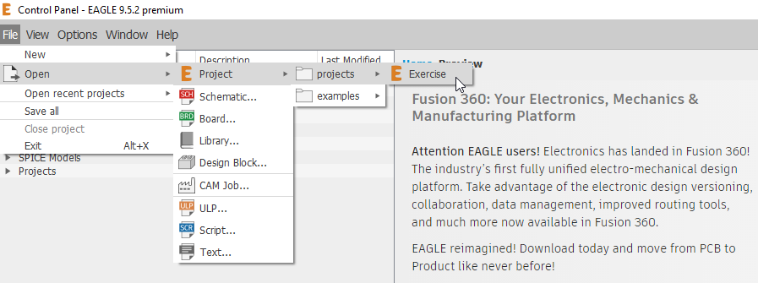

Figure 1: Open Project Exercise

Step 5: Let’s double-check schematic Exercise.sch. Click Exercise.sch as shown in Figure 2.

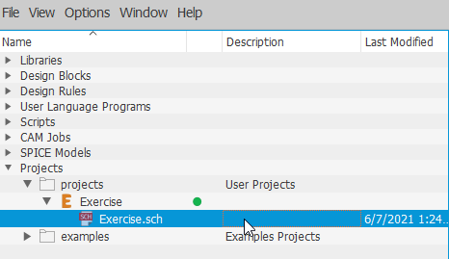

Figure 2: Open Exercise.sch again to double-check connections.

Step 6: Click SCH/BRD as shown in Figure 3 to “Generates switch to board”.

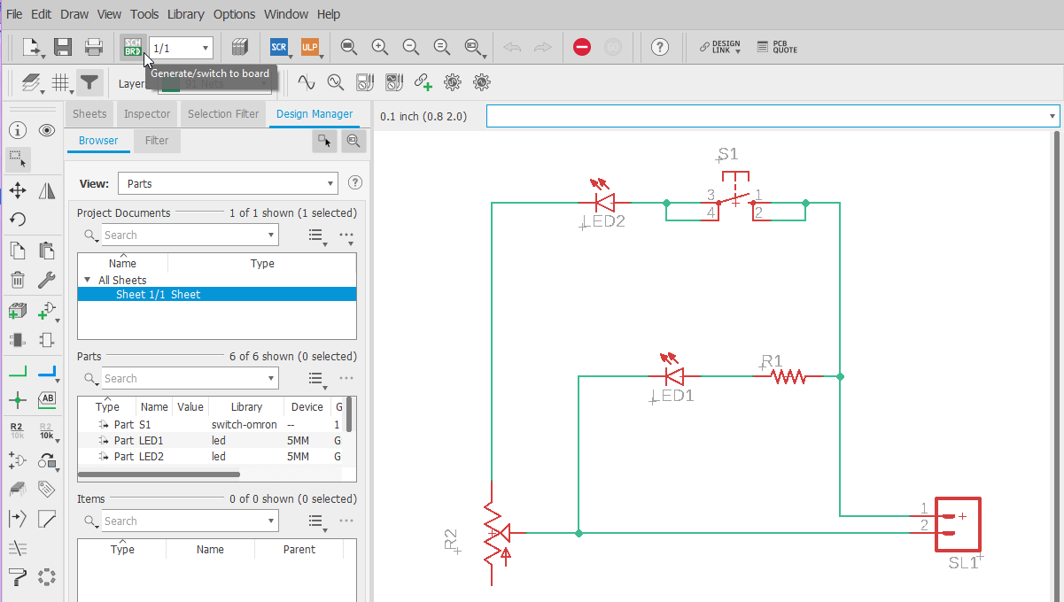

Figure 3: Switch to Board Layout

Step 7: Click Yes to popup. This will create Exercise.brd.

Step 8: Refer to Figure 4 to see original board setup.

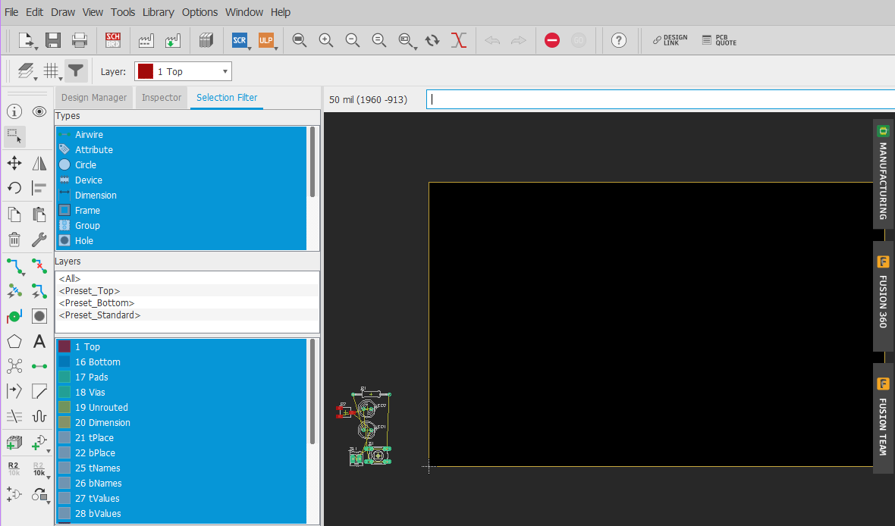

Figure 4: Original Board Layout

Step 9: Shrink the Board Outline by grabbing edges. Left-click and hold button, and move edge.

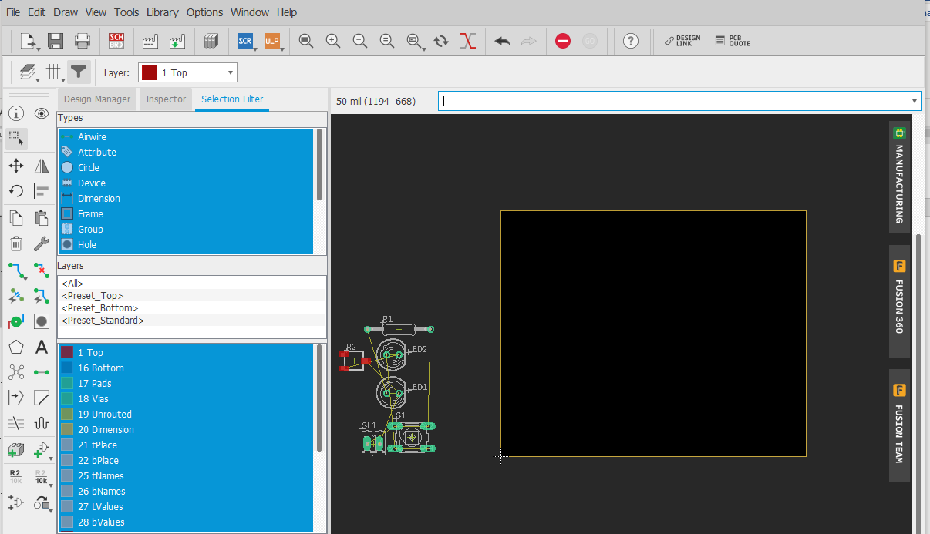

Figure 5: Resized Board Layout

* Use the scroll wheel on mouse to zoom in and out in Board Layout.

Step 10: Move parts inside dark black box. You can just left click and hold part with mouse to move part. Be sure to grab part in the center where the + resides. Release mouse button to place. Refer to Figure 6.

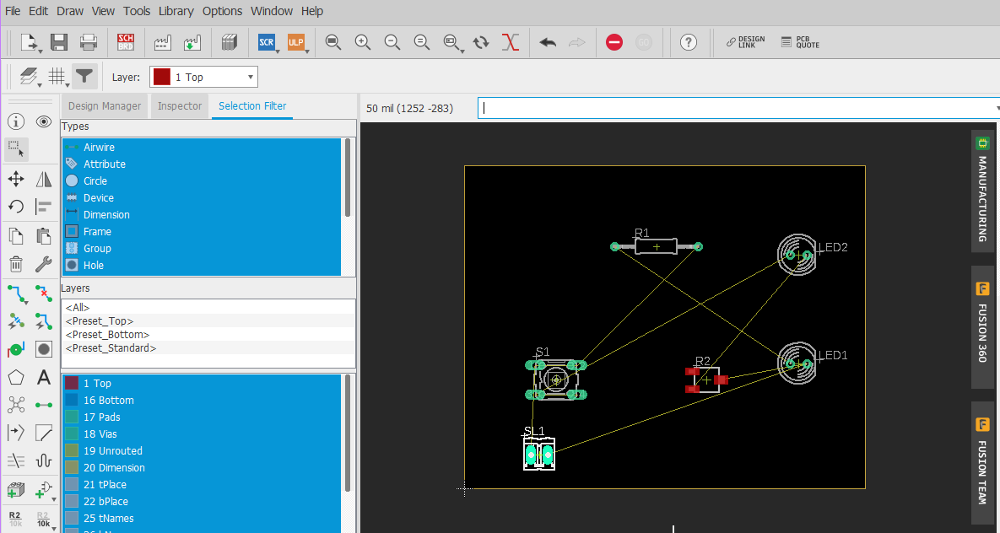

Figure 6: Parts inside Board.

* Try to eliminate criss-cross connections or Airwires.
* Be mindful of any board layout constraints. **You may want parts in certain locations on the board!**
* You may have to Rotate parts!

Step 11: Rotate R1. Remember Esc key ends operation. See Figure 7.

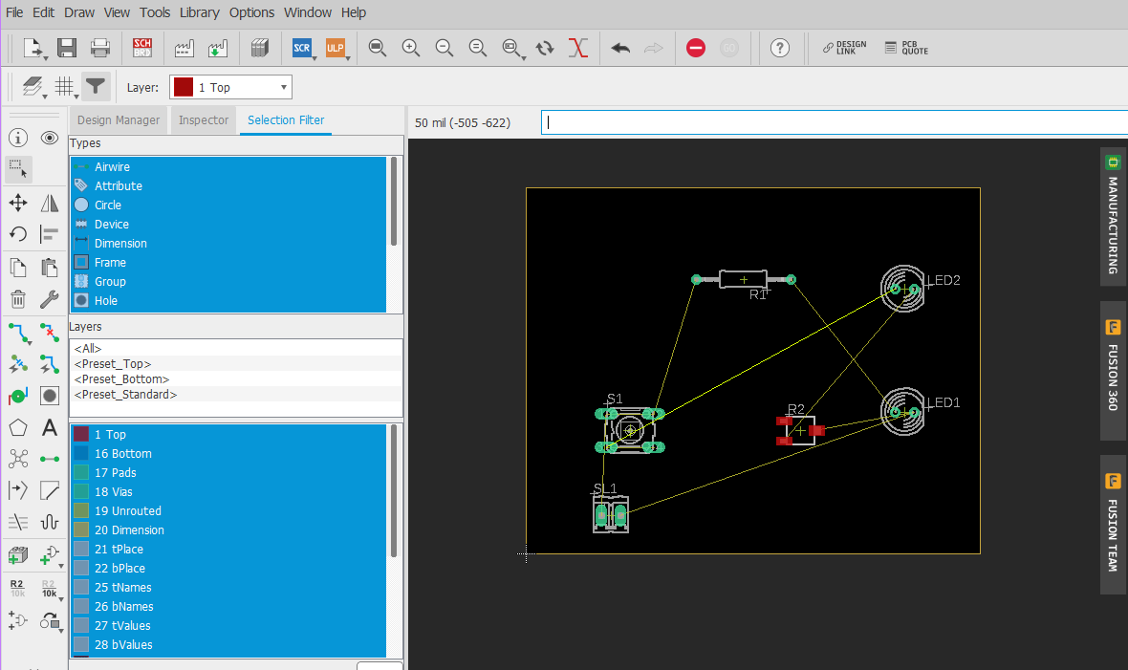

Figure 7: Rotated R1.

Step 12: Set the Grid Size to 5 mil. Click View, the Grid. See Figure 8. This gives us little more control on moving things easier.

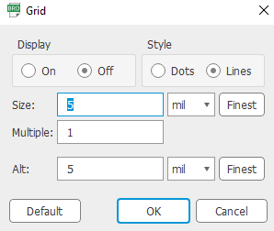

Figure 8: Set Grid to 5 mils.

Step 9: OK go to work. Move parts around to match Figure 9.

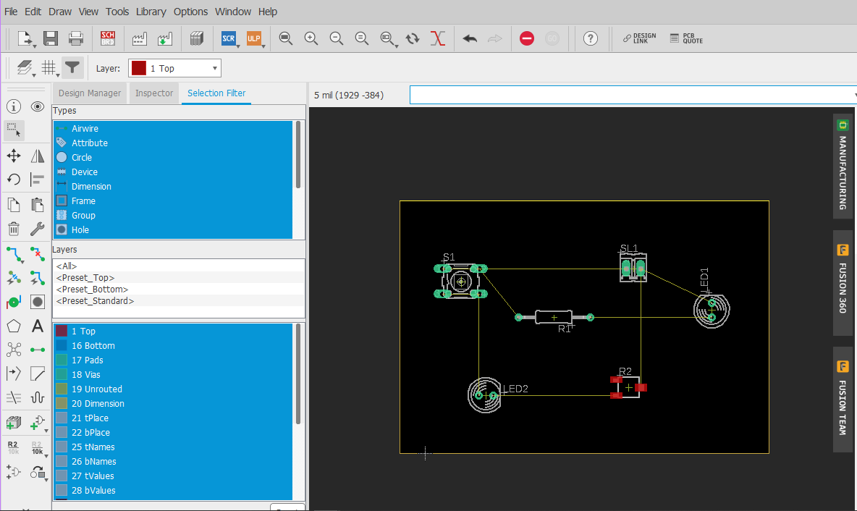

Figure 9: Final Layout

Step 10: Load Voltera-DRU. Click Tools, then DRC as shown in Figure 10.

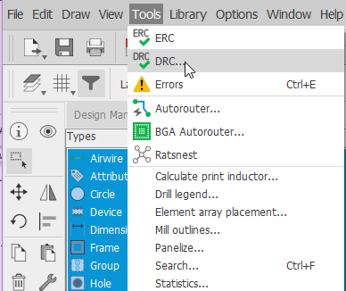

Figure 10: Click Tools, DRC

Step 11: Click Load in the bottom right corner of Figure 11.

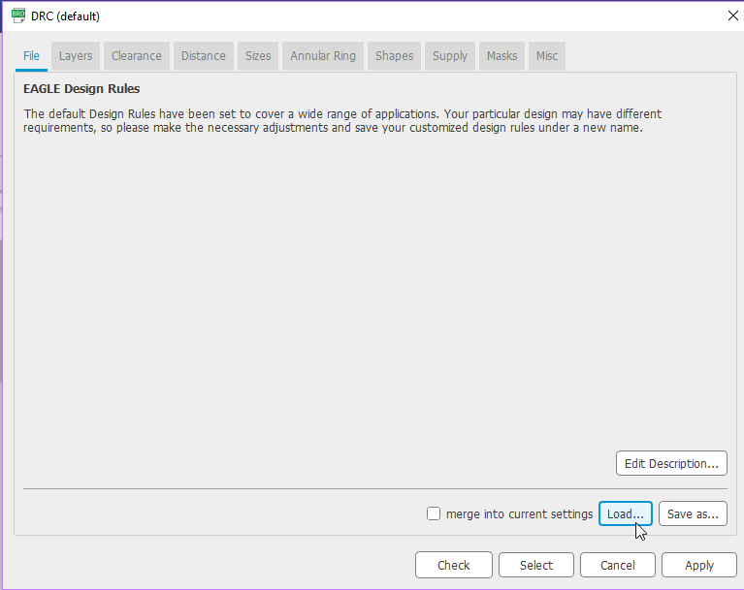

Figure 11: DRC Load

Step 12: Open voltera-dru.dru

Step 13: Click Apply voltera-dru as shown in Figure 12.

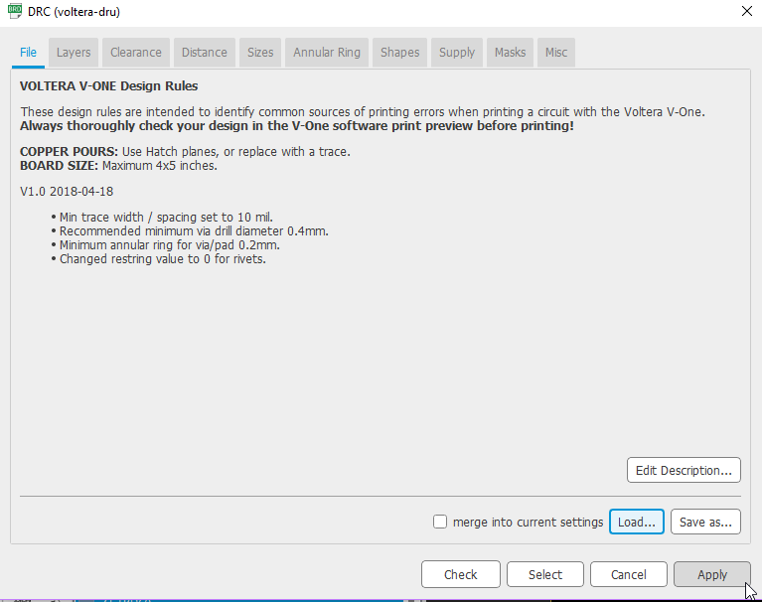

Figure 12: Apply voltera-dru.

Step 14: Now set the minimum size for traces to 12 mil as shown in Figure 13. Click Apply. Now Click X at top right corner to close the window.

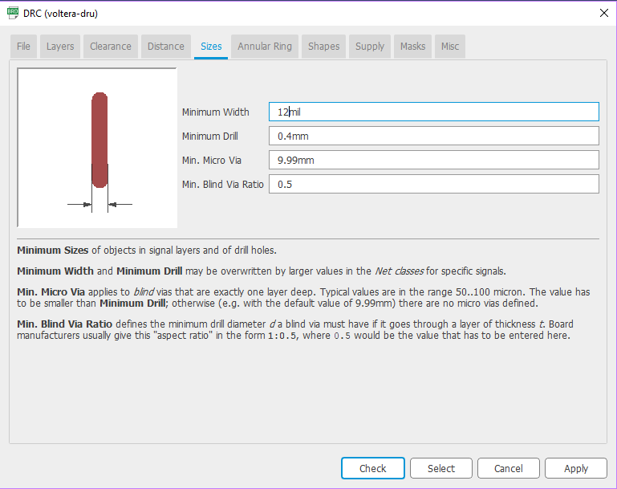

Figure 13: Set minimum trace width to 12mil.

Step 15: Start Routing Wires. Click Route Airwire as shown in Figure 14.

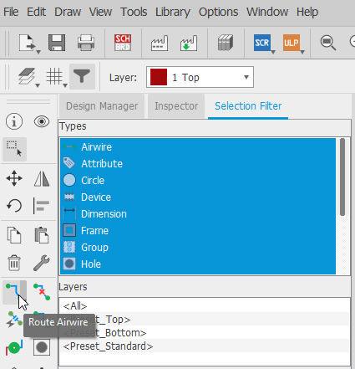

Figure 14: Route Airwire

Step 16: Route first trace between S1 and SL1 as shown in Figure 15. Click pad of S1 then SL1.

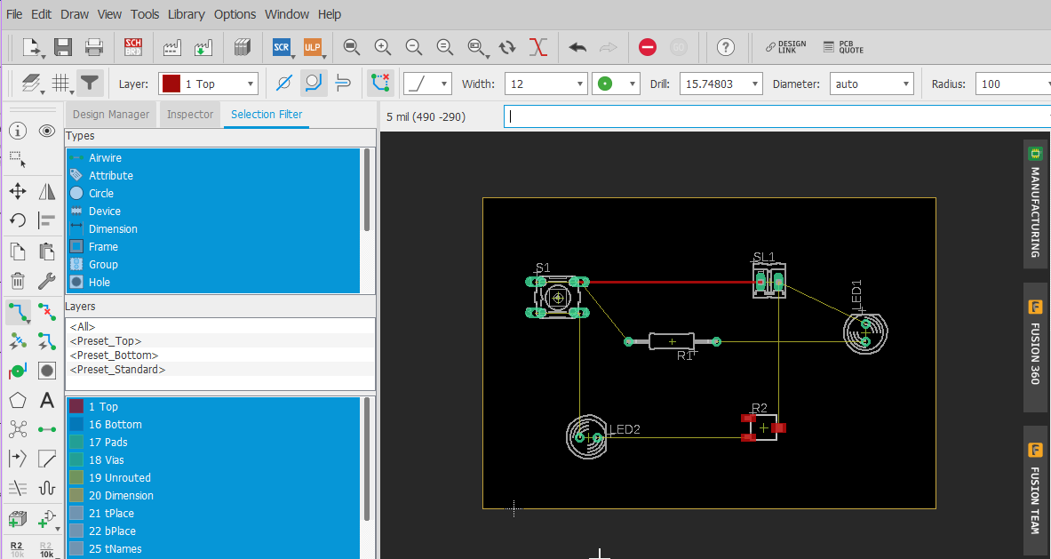

Figure 15: Route Trace from S1 to SL1

Step 17: Route rest of traces as shown in Figure 16.

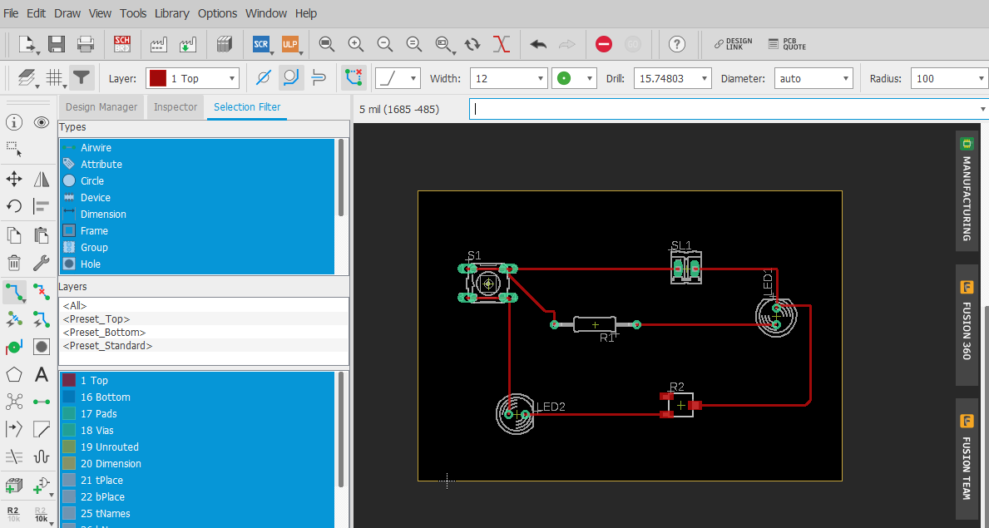

Figure 16: Route Traces.

Step 18: Run DRU to ensure there are no errors. Click Tools, CRC, then Check. You may get some Errors as shown in Figure 17.

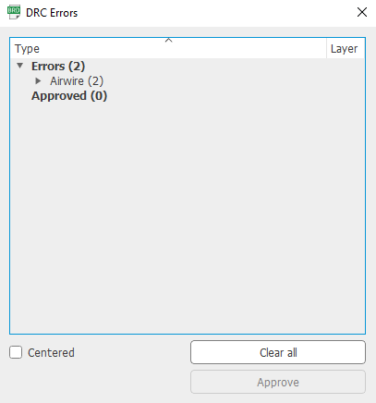

Figure 18: DRC Errors Appear

Step 19: Click the Airwire Error as shown in Figure 19 to go to problem on the board.

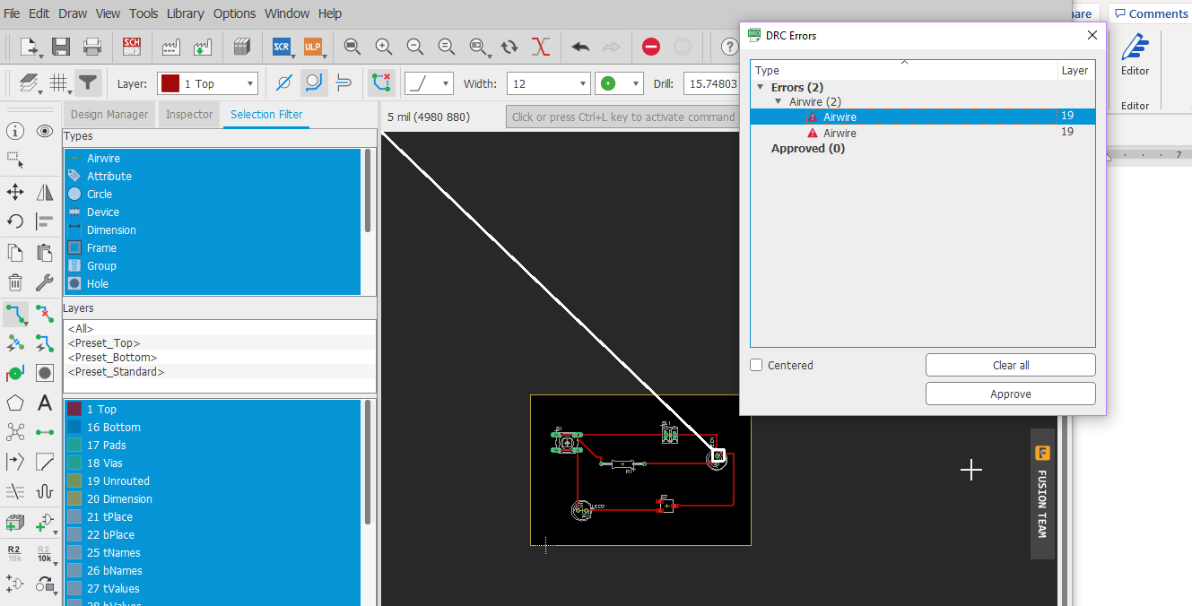

Figure 19: First Airwire Error

Step 20: Zoom in to see close-up of Airwire as shown in Figure 20.

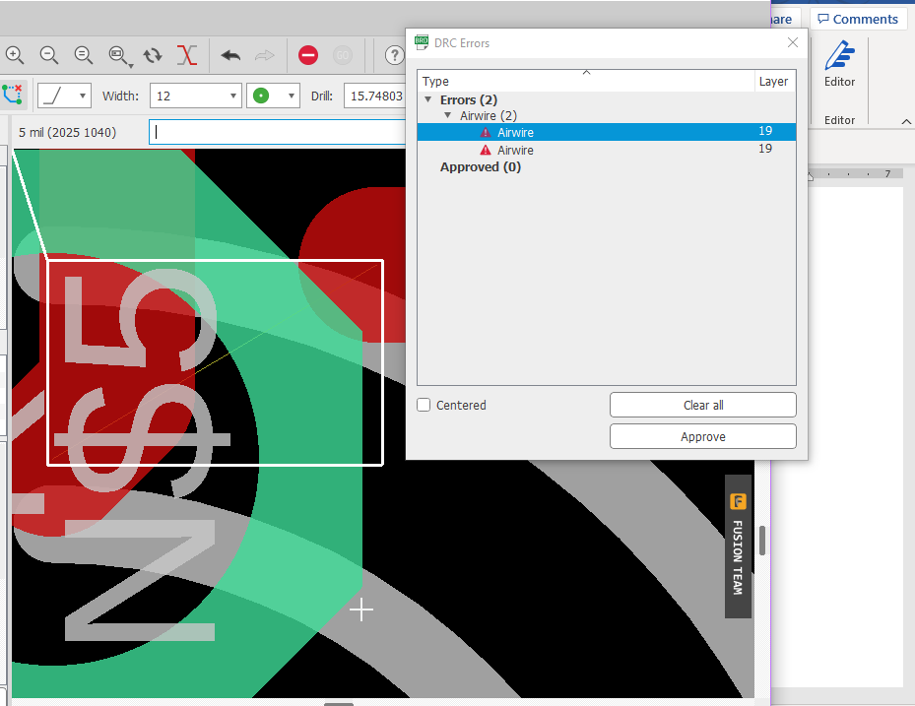

Figure 19: First Airwire Error

Step 20: Small portion of trace is not completed. Route the small trace. You should start by getting a big X on the Airwire to complete. Route it to the pad. See Figure 20.

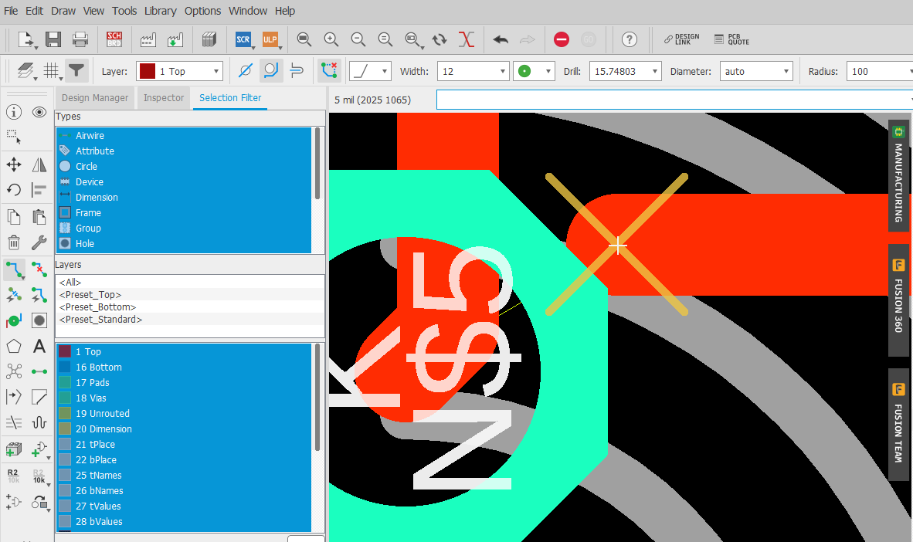

Figure 20: Route small portion of Airwire.

Step 21: Run DRU check again to see if Airwire error disappeared. First Airwire fixed as shown in Figure 21.

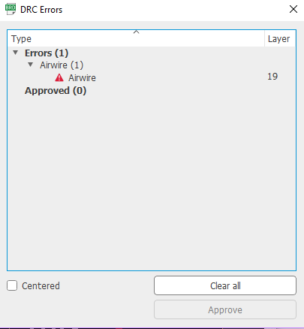

Figure 21: First Airwire Fixed

Step 22: Click the second Airwire. Refer to Figure 22 for second Airwire error. Re-route the small portion of trace.

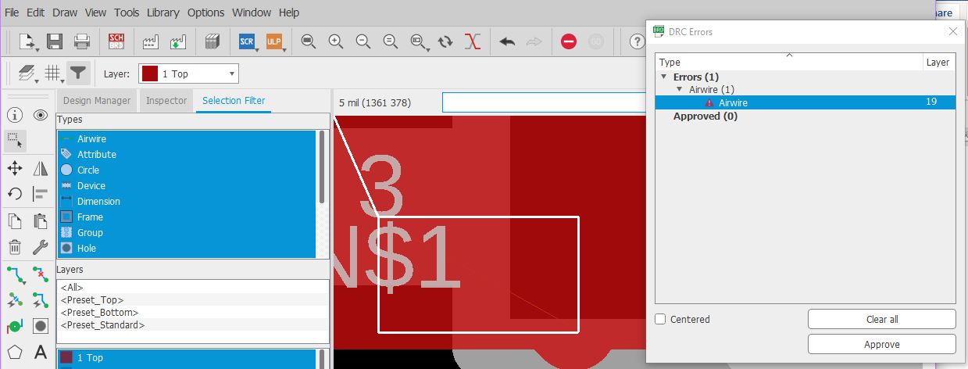

Figure 22: Second Airwire.

Step 23: Run DRC again. Fix one problem and introduce another as shown in Figure 23. Ripout the small trace.

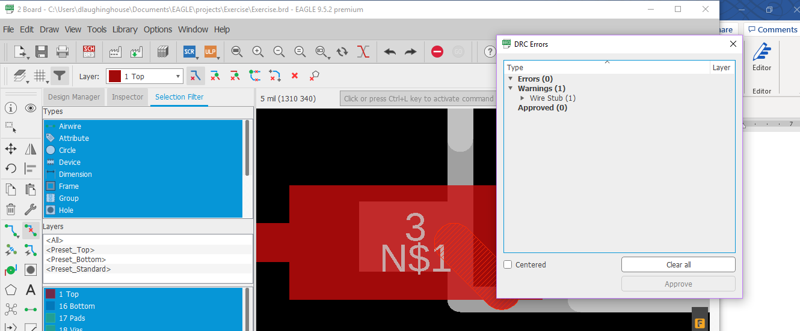

Figure 23: Wire Stub Error.

Step 24: Run DRC check again and errors disappear.

Step 25: DEMO rest in class.